Event Planning Tool

SOFTWARE REQUIREMENTS SPECIFICATION DOCUMENT

Hafsah Ashraf

FL-21153

Farwah Mahnoor

SP-21280

Ali Hassan Lodhi

SP-21290

**Revision History**

|  |  |  |  |
| --- | --- | --- | --- |
| **Date** | **Version** | **Description** | **Author** |
| 29-April-2024 | 0.1 | Functionality of system, functional requirements and non-functional requirements | Hafsah Ashraf  Ali Hassan Lodhi  Farwah Mahnoor |
| 8-May-2024 | 0.2 | Use case diagram, object diagram, sequence diagram, communication diagram and Petri-Nets | Hafsah Ashraf  Ali Hassan Lodhi  Farwah Mahnoor |
|  |  |  |  |
|  |  |  |  |
|  |  |  |  |

Contents

1. Introduction 4

1.2 Purpose 4

1.2 Scope 4

2. The Overall Description 5

2.1 Product Functions 5

2.1.1 Event Creation and Management 5

2.1.2 Task Management and To-Do Lists 5

2.1.3 Budgeting and Expense Tracking 5

2.1.4 Vendor and Supplier Management 5

2.1.5 Guest List Management 6

2.1.6 Venue Selection and Management 6

2.1.7 Calendar Integration and Scheduling 6

2.1.8 Collaboration and Communication Tools 6

2.1.9 Analytics and Reporting 6

3. Specific Requirements 6

3.1 Event Creation and Management 6

3.2 Task Management and To-Do Lists 6

3.3 Budgeting and Expense Tracking 7

3.4 Vendor and Supplier Management 7

3.5 Guest List Management 7

3.6 Venue Selection and Management 7

3.7 Calendar Integration and Scheduling 8

3.8 Collaboration and Communication Tools 8

3.9 Analytics and Reporting 8

4. Functional Requirements 8

4.1 Performance 8

4.2 Reliability 8

4.3 Security 9

4.4 Usability 9

4.5 Compatibility 9

4.6 Maintainability 9

4.7 Performance Monitoring 9

4.8 Compliance 10

5. Use Case Model 11

6. Object Diagram 11

7. Sequence Diagram 13

8. Communication Diagram 14

9. Petr-Nets 14

# 1. Introduction

The Event Planning System is designed to streamline the process of organizing and managing events. It provides a comprehensive suite of tools to facilitate efficient event creation, management, task coordination, budget tracking, vendor communication, guest list management, venue selection, scheduling, collaboration, and reporting.

## 1.2 Purpose

SRS stands for Software Requirements Specification. It defines what the software will do and how it will do it. It also defines the functionality that the product will need to meet the needs of all stakeholders (enterprise, users).

The purpose of this SRS is to provide readers and users with information about the system and the functions and specifications of the system. SRS describes the requirements of the system in terms of data, functionality and behavior.

The development of this new system contains the following activities, which try to automate the entire process keeping in the view of database integration approach. This system maintains employees’ personal, addresses, and contact details. User-friendliness is provided in the application with various controls provided by system rich user interface. This system allows the employees to manage the events systematically.

## 1.2 Scope

The objective of this application is to develop a system that effectively manages all the data related to the various events that take place in an organization. The purpose of the “Event Planning Tool” is to provide a better way to select event halls for different events like Wedding Functions, College parties, Political Meetings, etc. Online EventManagement System manages events like live shows, Birthday Events, and Concerts; Wedding Events Users can see the decoration of halls, the style of halls and can book them online without going to the management office.

# 2. The Overall Description

Sometimes, events don’t get the attention they deserve. The primary communication channel for these events is a poster or a mouth to mouth (MTS). It’s becoming increasingly clear that these channels are becoming outdated. Recently, Twitter and Facebook have proven to be more receptive to communication via a Client and attendees. To keep up with this trend, we’re implementing this system to facilitate communication between the client and the event-goers. We’ll also provide up-to-date updates and event information.

## 2.1 Product Functions

An event planning system typically encompasses various functionalities aimed at facilitating the organization, management, and execution of events, ranging from small gatherings to large conferences. It shall perform following functions.

### 2.1.1 Event Creation and Management

**Purpose:** This functionality allows users to create new events, specifying details such as event type, date, time, location, and description. Users can also manage existing events, view event details, and make necessary updates.

### 2.1.2 Task Management and To-Do Lists

**Purpose:** Helps users organize and prioritize tasks related to event planning, such as booking venues, hiring vendors, sending invitations, and managing logistics. Users can create, assign, and track tasks, ensuring that all necessary steps are completed on time.

### 2.1.3 Budgeting and Expense Tracking

**Purpose:** Enables users to create and manage event budgets, allocating funds to different categories such as venue, catering, entertainment, and marketing. Users can track expenses, monitor budget vs. actual spending, and generate financial reports to ensure cost control and accountability.

### 2.1.4 Vendor and Supplier Management

**Purpose:** Facilitates the management of relationships with vendors and suppliers involved in the event, such as venues, caterers, decorators, and entertainers. Users can store vendor contact information, track contracts and agreements, and communicate requirements and deadlines.

### 2.1.5 Guest List Management

**Purpose:** Allows users to create and manage guest lists and communicate with attendees. Users can send invitations, manage guest preferences (such as dietary restrictions), and send event updates and reminders.

### 2.1.6 Venue Selection and Management

**Purpose:** Assists users in selecting and managing event venues, considering factors such as capacity, location, amenities, and cost. Users can search for venues, compare options, view availability, book reservations, and coordinate logistics with venue staff.

### 2.1.7 Calendar Integration and Scheduling

**Purpose:** Integrates event schedules with users' calendars, helping them manage their time and avoid scheduling conflicts. Users can view event dates and times, set reminders, and synchronize event schedules with their personal calendars for better organization.

### 2.1.8 Collaboration and Communication Tools

**Purpose:** Facilitates communication and collaboration among event organizers, team members, clients, vendors, and other stakeholders. Users can share documents, exchange messages, schedule meetings, and collaborate on event plans in real-time, enhancing efficiency and teamwork.

### 2.1.9 Analytics and Reporting

**Purpose:** Provides insights into various aspects of event planning and performance through data analysis and reporting. Users can generate reports on attendance, revenue, expenses, feedback, and other key metrics, helping them evaluate the success of events and make data-driven decisions for future planning.

# 3. Specific Requirements

3.1 Functional Requirements

## 3.1 Event Creation and Management

**Create Event:** Users should be able to create new events, providing details such as event name, date, location, description, and type.

**Edit Event:** Users should have the ability to modify event details after creation.

**Cancel Event:** Ability to cancel events with appropriate notifications to relevant stakeholders.

**Event Duplication:** Capability to duplicate events to save time on repetitive tasks.

## 3.2 Task Management and To-Do Lists

**Create Tasks:** Users can create tasks, assign them to team members, set deadlines, and prioritize them.

**Task Status Tracking:** Ability to track the status of tasks (e.g., pending, in progress, completed).

**Task Assignment:** Users can assign tasks to specific team members and receive notifications on task updates.

## 3.3 Budgeting and Expense Tracking

**Budget Creation:** Users should be able to create budgets for events, including estimated and actual expenses.

**Expense Tracking:** Ability to track expenses, categorize them, and compare them against the budget.

**Expense Approval:** Allow designated users to approve or reject expense requests.

## 3.4 Vendor and Supplier Management

**Vendor Database:** Maintain a database of vendors/suppliers, including contact information and services provided.

**Vendor Communication:** Enable communication with vendors/suppliers regarding quotes, contracts, and deliverables.

**Vendor Performance Tracking:** Track vendor performance based on factors like reliability, quality, and timeliness.

## 3.5 Guest List Management

**Create Guest List:** Users can create guest lists, import contacts, and categorize guests.

**RSVP Management:** Track RSVP responses from guests and manage attendance lists.

**Guest Communication:** Send invitations, reminders, and updates to guests via email or SMS.

## 3.6 Venue Selection and Management

**Venue Search:** Provide a search function to find suitable venues based on criteria like location, capacity, and amenities.

**Venue Booking:** Ability to book venues and manage bookings, including contracts and payments.

**Venue Logistics:** Manage logistics related to venues, such as setup, catering, and technical requirements.

## 3.7 Calendar Integration and Scheduling

**Calendar Sync:** Integrate with popular calendar applications to sync event schedules.

**Scheduling:** Enable scheduling of tasks, meetings, and deadlines within the system.

**Conflict Resolution:** Automatically detect and resolve scheduling conflicts.

## 3.8 Collaboration and Communication Tools

**Team Collaboration:** Provide tools for team members to collaborate, share documents, and communicate effectively.

**Guest Communication:** Enable communication with guests, vendors, and suppliers through integrated messaging tools.

**Real-Time Updates:** Ensure real-time updates on event progress and changes to all relevant stakeholders.

## 3.9 Analytics and Reporting

**Data Visualization:** Generate visual reports on various aspects of event planning, such as budget vs. actual expenses, task completion rates, and guest attendance.

**Custom Reporting:** Allow users to create custom reports based on specific criteria and filters.

**Performance Metrics:** Track key performance indicators (KPIs) to assess the success of events and identify areas for improvement.

# 4. Functional Requirements

## 4.1 Performance

**Response Time:** The system should respond to user interactions within milliseconds for smooth user experience.

**Scalability:** The system should be scalable to handle a large number of users, events, and data without performance degradation.

## 4.2 Reliability

**- Availability:** Ensure high availability of the system, with minimal downtime for maintenance or upgrades.

**Data Integrity:** Implement measures to maintain data integrity and prevent data loss or corruption.

## 4.3 Security

**Authentication:** Users should be required to authenticate themselves before accessing the system.

**Authorization:** Implement role-based access control to restrict access to sensitive features and data.

**Data Encryption:** Encrypt sensitive data such as user credentials, financial information, and personal data.

## 4.4 Usability

**Intuitive Interface:** Design an intuitive and user-friendly interface to facilitate ease of use.

**Accessibility:** Ensure accessibility for users with disabilities, complying with relevant accessibility standards.

**Multilingual Support:** Provide support for multiple languages to accommodate users from diverse backgrounds.

## 4.5 Compatibility

**Browser Compatibility:** Ensure compatibility with major web browsers such as Chrome, Firefox, Safari, and Edge.

**Device Compatibility:** Support access from various devices, including desktops, laptops, tablets, and smartphones.

## 4.6 Maintainability

**Modularity:** Design the system with a modular architecture to facilitate easy maintenance and updates.

**Documentation:** Provide comprehensive documentation covering system architecture, functionality, APIs, and deployment procedures.

## 4.7 Performance Monitoring

**Logging:** Implement logging mechanisms to track system events, errors, and user activities for troubleshooting and auditing purposes.

**Monitoring Tools:** Integrate monitoring tools to track system performance, resource utilization, and user behavior.

## 4.8 Compliance

**Regulatory Compliance:** Ensure compliance with relevant regulations and standards, such as data protection laws (e.g., GDPR, CCPA) and industry standards (e.g., ISO 27001).

**Privacy:** Implement measures to protect user privacy and confidentiality of data, including anonymization and pseudonymization where appropriate.

This requirement specification document outlines the functional and non-functional requirements for the Event Planning System, providing a comprehensive framework for its development and implementation.

# 5. Use Case Model

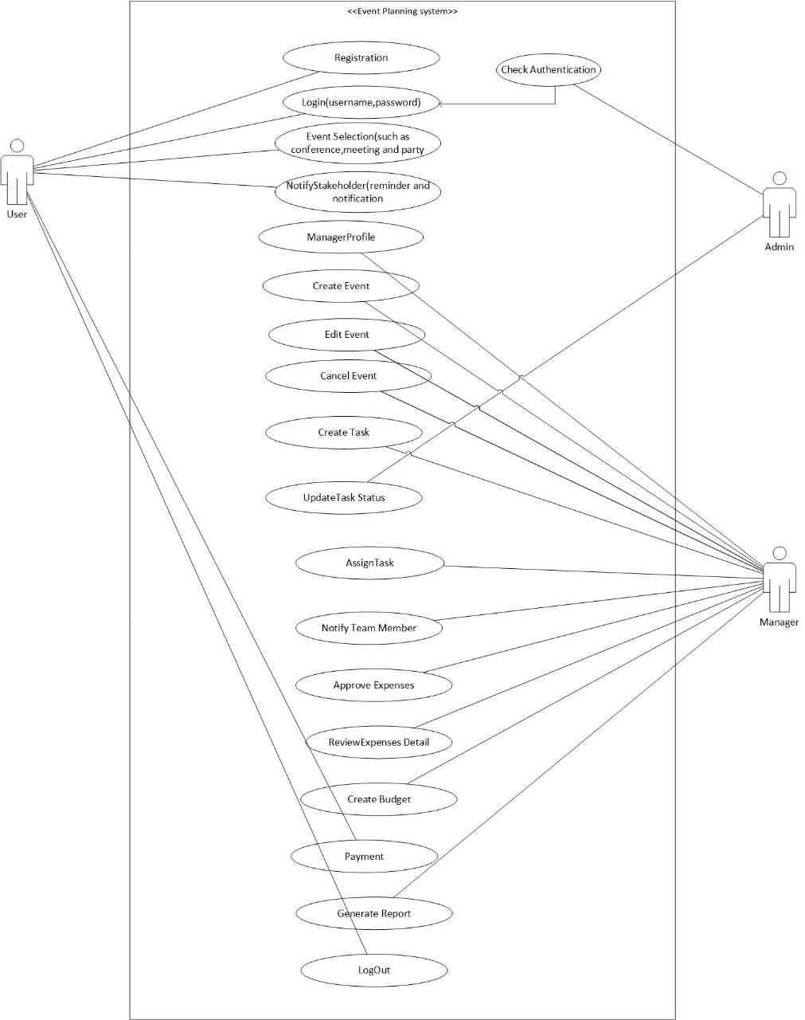

# 6. Object Diagram

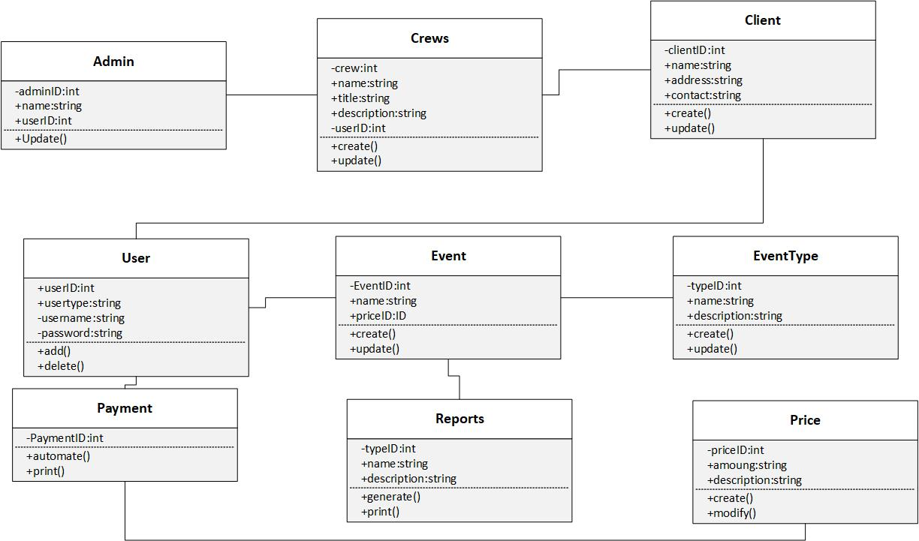

# 7. Sequence Diagram

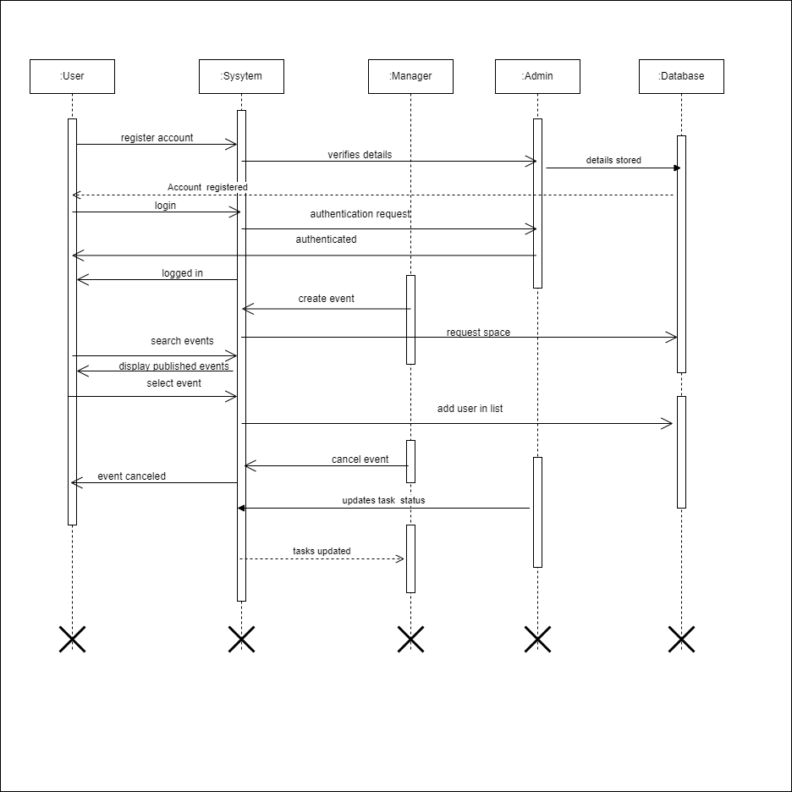

# 8. Communication Diagram

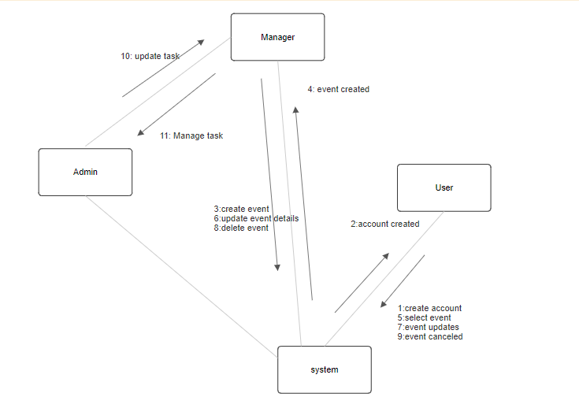

# 9. Petr-Nets

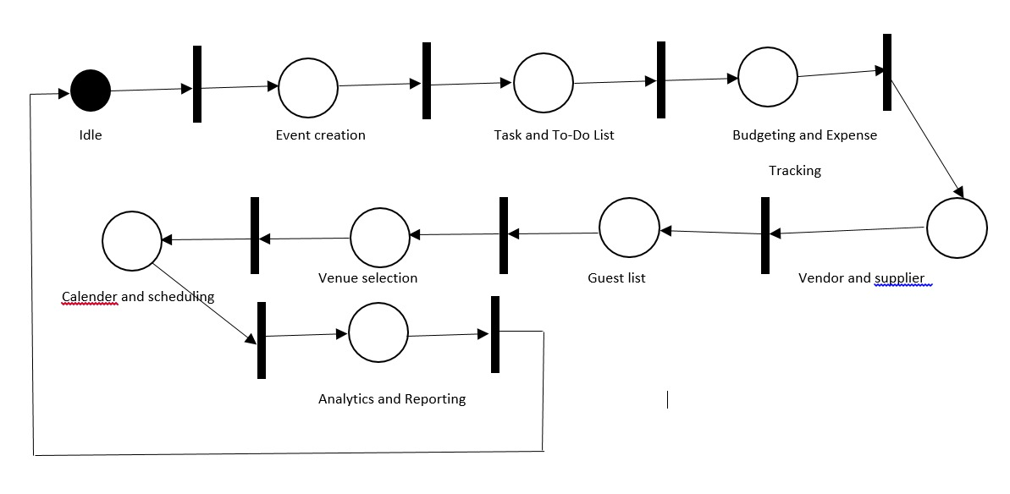

# 10. Test-cases

